2017-18 Wisconsin State Legislators, by Technical College District
Contents
BLACKHAWK TECHNICAL COLLEGE 2
CHIPPEWA VALLEY TECHNICAL COLLEGE 3
FOX VALLEY TECHNICAL COLLEGE 5
GATEWAY TECHNICAL COLLEGE 8
LAKESHORE TECHNICAL COLLEGE 10
MADISON AREA TECHNICAL COLLEGE 11
MID-STATE TECHNICAL COLLEGE 14
MILWAUKEE AREA TECHNICAL COLLEGE 16
MORAINE PARK TECHNICAL COLLEGE 19
NICOLET AREA TECHNICAL COLLEGE 21
NORTHCENTRAL TECHNICAL COLLEGE 22
NORTHEAST WISCONSIN TECHNICAL COLLEGE 24
SOUTHWEST WISCONSIN TECHNICAL COLLEGE 26
WAUKESHA COUNTY TECHNICAL COLLEGE 27
WESTERN TECHNCAL COLLEGE 29
WISCONSIN INDIANHEAD TECHNICAL COLLEGE 30
It should be noted that legislators for the following districts are not currently listed:
- 1st Senate District – NWTC, Fox Valley, LTC. Senator Lassee resigned his seat to accept a job with Governor Walker’s administration
- 42nd Assembly District – Madison College and Moraine Park. Rep. Ripp resigned his seat to accept a job with Governor Walker’s administration.
- There will be no special election to replace them.
In addition, there are no legislators listed for the following districts. These seats are currently vacant. There will be an election on January 16 to replace the legislators for the following seats:
- 58th Assembly District – Moraine Park Technical College (formerly held by Rep Gannon)
- 66th Assmebly District - Gateway Technical College (formerly held by Rep Mason)
- 10th Senate District – Chippewa Valley Technical College (formerly held by Senator Harsdorf)

BLACKHAWK TECHNICAL COLLEGE
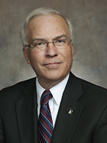 | 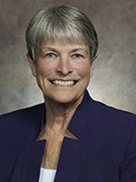 | 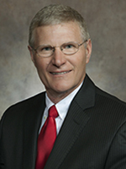 | 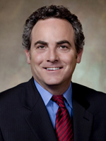
Senator Steve Nass  (Whitewater) | Senator Janis Ringhand  (Evansville) | Senator Howard Marklein  (Spring Green) | Senator Jon Erpenbach  (Waunakee)

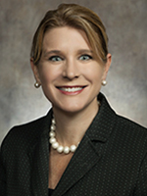 | 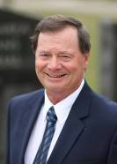 | 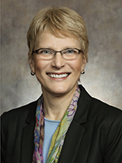 | 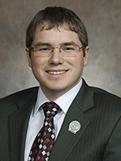
Rep. Amy Loudenbeck  (Clinton) | Rep. Don Vruwink  (Milton) | Rep. Debra Kolste  (Janesville) | Rep. Mark Spreitzer  (Beloit)
 | 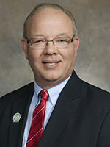 | 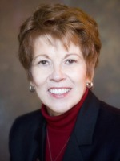
 | Rep. Todd Novak  (Dodgeville) | Rep. Sondy Pope  (Cross Plains)

CHIPPEWA VALLEY TECHNICAL COLLEGE
(SENATORS)
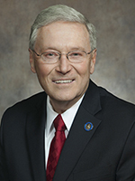 | 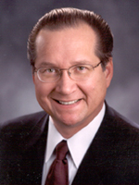 | 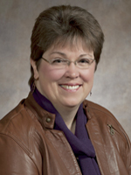 | 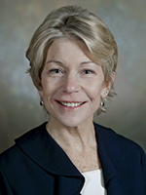
Senator Terry Moulton  (Chippewa Falls) | Senator Jerry Petrowski  (Marathon) | Senator Kathleen Vinehout  (Alma) | Senator Janet Bewley  (Ashland)

CHIPPEWA VALLEY TECHNICAL COLLEGE (REPRESENTATIVES)
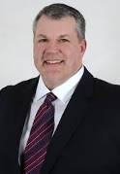 | 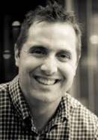 | 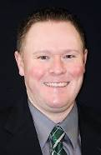 | 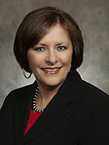
Rep. Rob Stafsholt  (New Richmond) | Rep. Shannon Zimmerman  (River Falls) | Rep. Rob Summerfield  (Bloomer) | Rep. Kathy Bernier  (Chippewa Falls)
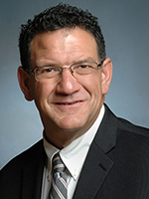 | 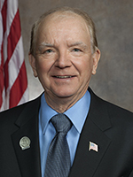 | 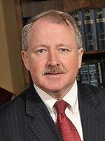 | 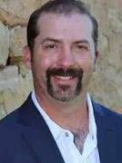
Rep. Bob Kulp  (Stratford) | Rep. James Edming  (Glen Flora) | Rep. Dana Wachs  (Eau Claire) | Rep. Treig Pronschinski  (Mondovi)
 | 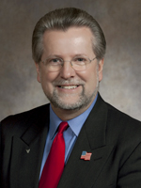 | 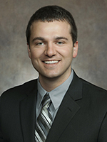
 | Rep. Warren Petryk  (Eleva) | Rep. Romaine Quinn  (Rice Lake)

FOX VALLEY TECHNICAL COLLEGE
(SENATORS)
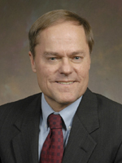 | 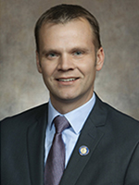 | 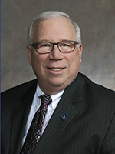 | 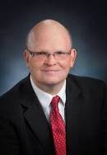
Senator Rob Cowles  (Green Bay) | Senator Devin LeMahieu  (Oostburg) | Senator Luther Olsen  (Ripon) | Senator Dan Feyen  (Fond du Lac)
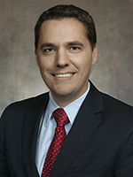 | 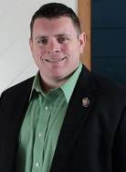 | 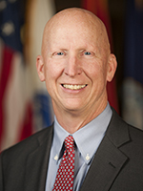
Senator Roger Roth  (Appleton) | Senator Patrick Testin  (Stevens Point) | Senator Duey Stroebel  (Saukville)

FOX VALLEY TECHNICAL COLLEGE (REPRESENTATIVES)
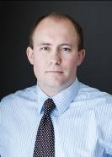 | 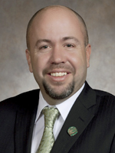 | 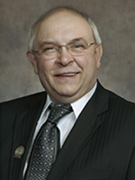 | 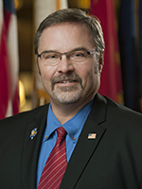
Rep. Ron Tusler  (Appleton) | Rep. Jim Steineke  (Kaukana) | Rep. Gary Tauchen  (Bonduel) | Rep. Paul Tittl  (Manitowoc)
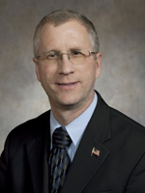 | 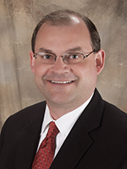 | 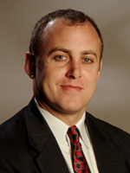 | 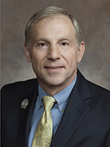
Rep. Kevin Petersen  (Waupaca) | Rep. Michael Schraa  (Oshkosh) | Rep. Gordon Hintz  (Oshkosh) | Rep. Mike Rohrkaste  (Neenah)
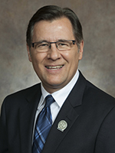 | 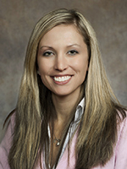 | 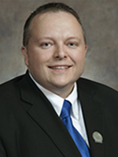 | 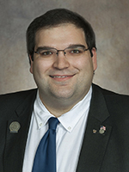
Rep. Dave Murphy  (Greenville) | Rep. Amanda Stuck  (Appleton) | Rep. Scott Krug  (Wisconsin Rapids) | Rep. Andre Jacque  (Green Bay)

FOX VALLEY TECHNICAL COLLEGE (REPRESENTATIVES CONT’D)

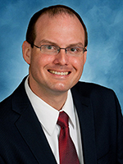 | 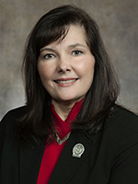
Rep. Jesse Kremer  (Kewaskum) | Rep. Nancy VanderMeer  (Tomah)

GATEWAY TECHNICAL COLLEGE
(SENATORS)
 | 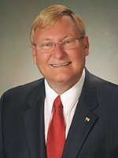 | 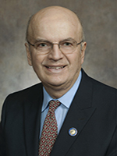 | 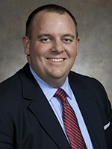
Senator Steve Nass  (Whitewater) | Senator Van Wanggaard  (Racine) | Senator Bob Wirch  (Pleasant Prairie) | Senator Dave Craig  (Big Bend)
Senator Janis Ringhand
(Evansville)

GATEWAY TECHNICAL COLLEGE (REPRESENTATIVES)
 | 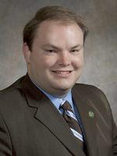 | 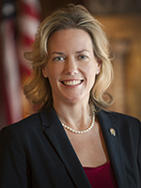 | 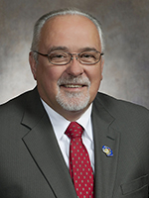
Rep. Amy Loudenbeck  (Clinton) | Rep. Tyler August  (Walworth) | Rep. Samantha Kerkman  (Powers Lake) | Rep. Tom Weatherston  (Racine)
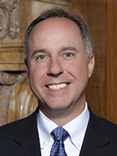 | 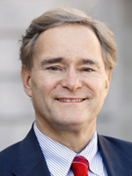 | 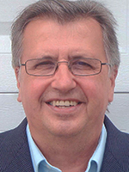 | 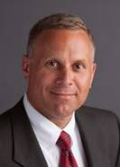
Rep. Robin Vos  (Burlington) | Rep. Peter Barca  (Kenosha) | Rep. Tod Ohnstad  (Kenosha) | Rep. Chuck Wichgers  (Muskego)
 | 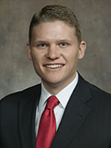
 | Rep. Cody Horlacher  (Mukwonago) | Rep. Don Vruwink  (Milton)

LAKESHORE TECHNICAL COLLEGE
Senator Devin LeMahieu  (Oostburg) | Senator Duey Strobel  (Saukville)

 |  | 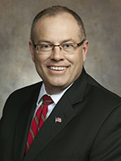 | 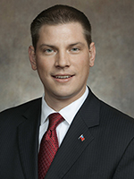
Rep. Andre Jacque  (Green Bay) | Rep. Paul Tittl  (Manitowoc) | Rep. Terry Katsma  (Oostburg) | Rep. Tyler Vorpagel  (Plymouth)
 | 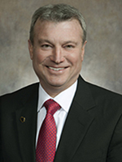 | 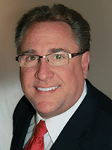
Rep. Jesse Kremer  (Kewaskum) | Rep. Joel Kitchens  (Sturgeon Bay) | Rep. Robert Brooks  (Saukville)

MADISON AREA TECHNICAL COLLEGE
(SENATORS)
 | 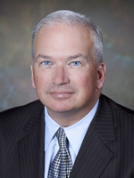
Senator Steve Nass  (Whitewater) | Senator Scott Fitzgerald  (Juneau) | Senator Luther Olsen  (Ripon) | Senator Janis Ringhand  (Evansville)
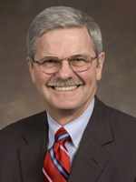 |  | 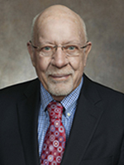
Senator Mark Miller  (Monona) | Senator Howard Marklein  (Spring Green) | Senator Fred Risser  (Madison) | Senator Jon Erpenbach  (Waunakee)

MADISON AREA TECHNICAL COLLEGE (REPRESENTATIVES)
 | 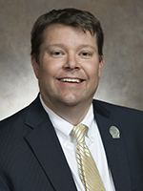 | 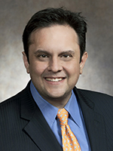 | 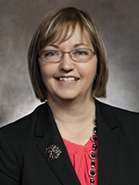
Rep. Cory Horlacher  (Mukwonago) | Rep. John Jagler  (Watertown) | Rep. Joel Kleefisch  (Oconomowoc) | Rep. Joan Ballweg  (Markesan)
 | 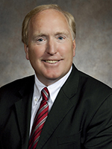 | 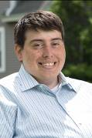 | 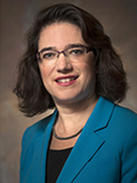
Rep. Don Vruwink  (Milton) | Rep. Gary Hebl  (Sun Prairie) | Rep. Jimmy Anderson  (Fitchburg) | Rep. Melissa Sargent  (Madison)
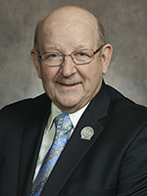 | 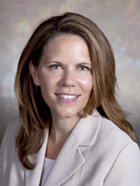 | 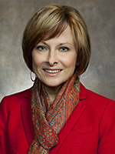 | 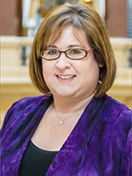
Rep. Ed Brooks  (Reedsburg) | Rep. Chris Taylor  (Madison) | Rep. Terese Berceau  (Madison) | Rep. Lisa Subeck  (Madison)

MADISON COLLEGE (REPRESENTATIVES CONT’D)

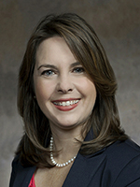 |  | 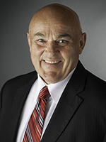
Rep. Dianne Hesselbein  (Middleton) | Rep. Sondy Pope  (Cross Plains) | Rep. Dave Considine  (Baraboo) | Rep. Todd Novak  (Dodgeville)

MID-STATE TECHNICAL COLLEGE
(SENATORS)
Senator Luther Olsen  (Ripon) | Senator Terry Moulton  (Chippewa Falls) | Senator Patrick Testin  (Stevens Point) | Senator Howard Marklein  (Spring Green)
Senator Jerry Petrowski
(Marathon)

MID-STATE TECHNICAL COLLEGE (REPRESENTATIVES)
 |  |  | 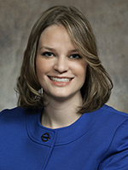
Rep. Joan Ballweg  (Markesan) | Rep. Bob Kulp  (Stratford) | Rep. Nancy VanderMeer  (Tomah) | Rep. Katrina Shankland  (Stevens Point)
 |  | 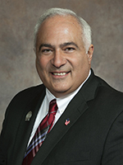
Rep. Scott Krug  (Wisconsin Rapids) | Rep. Ed Brooks  (Reedsburg) | Rep. John Spiros  (Marshfield)

MILWAUKEE AREA TECHNICAL COLLEGE
(SENATORS)
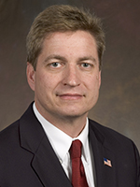 | 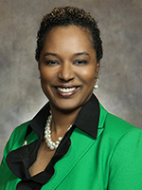 | 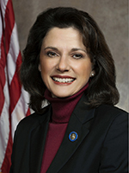 | 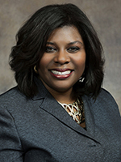
Senator Tim Carpenter  (Milwaukee) | Senator Lena Taylor  (Milwaukee) | Senator Leah Vukmir  (Wauwatosa) | Senator LaTonya Johnson  (Milwaukee)
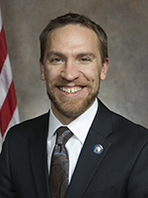 | 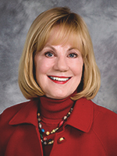
Senator Chris Larson  (Milwaukee) | Senator Alberta Darling  (River Hills) | Senator Duey Strobel  (Saukville) | Senator Dave Craig  (Big Bend)

MILWAUKEE AREA TECHNICAL COLLEGE (REPRESENTATIVES)
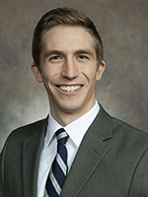 | 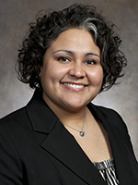 | 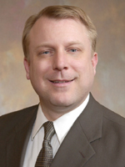 | 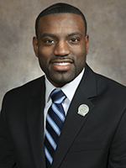
Rep. Daniel Riemer  (Milwaukee) | Rep. JoCasta Zamarripa  (Milwaukee) | Rep. Josh Zepnick  (Milwaukee) | Rep. David Bowen  (Milwaukee)
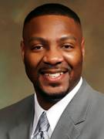 | 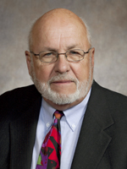 | 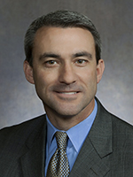 | 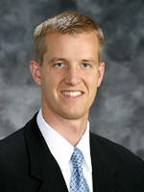
Rep. Jason Fields  (Milwaukee) | Rep. Fred Kessler  (Milwaukee) | Rep. Rob Hutton  (Brookfield) | Rep. Dale Kooyenga  (Brookfield)
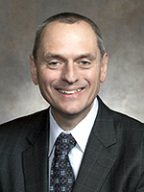 | 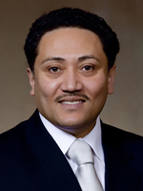 | 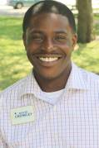 | 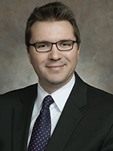
Rep. Joe Sanfelippo  (West Allis) | Rep. Leon Young  (Milwaukee) | Rep. David Crowley  (Milwaukee) | Rep. Evan Goyke  (Milwaukee)

MATC (REPRESENTATIVES CONT’D)

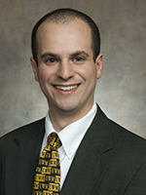 | 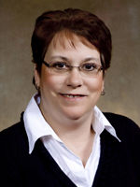 | 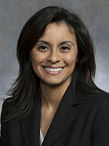 | 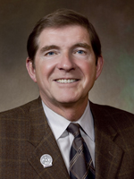
Rep. Jonathan Brostoff  (Milwaukee) | Rep. Christine Sinicki  (Milwaukee) | Rep. Jessie Rodriquez  (Franklin) | Rep. Jim Ott  (Mequon)
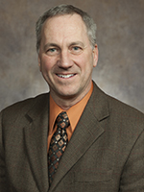 |  | 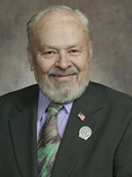 | 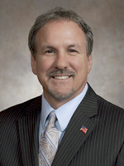
Rep. Dan Knodl  (Germantown) | Rep. Robert Brooks  (Saukville) | Rep. Ken Skowronski  (Franklin) | Rep. Mike Kuglitsch  (New Berlin)
 | 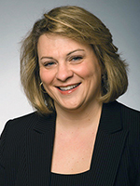
 | Rep. Janel Brandtjen  (Menomonee Falls) | Rep. Chuck Wichgers  (Muskego)

MORAINE PARK TECHNICAL COLLEGE
(SENATORS)
Senator Scott Fitzgerald  (Juneau) | Senator Luther Olsen  (Ripon) | Senator Dan Feyen  (Fond du Lac) | Senator Duey Strobel  (Saukville)
Senator Alberta Darling  (River Hills) | Senator Devin LeMahieu  (Oostburg) | Senator Patrick Testin  (Stevens Point)

MORAINE PARK TECHNICAL COLLEGE (REPRESENTATIVES)
 | 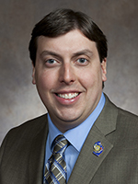 |  | 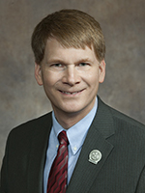
Rep. John Jagler  (Watertown) | Rep. Mark Born  (Beaver Dam) | Rep. Joan Ballweg  (Markesan) | Rep. Jeremy Thiesfeldt  (Fond du Lac)
Rep. Michael Schraa  (Oshkosh) | Rep. Jesse Kremer  (Kewaskum) | Rep. Robert Brooks  (Saukville) | Rep. Janel Brandtjen  (Menomonee Falls)
Rep. Paul Tittl  (Manitowoc) | Rep. Kevin Petersen  (Waupaca) | Rep. Scott Krug  (Wisconsin Rapids)

NICOLET AREA TECHNICAL COLLEGE
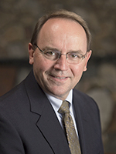
Senator Tom Tiffany  (Hazelhurst) | Senator Janet Bewley  (Ashland)

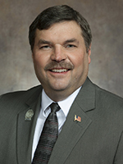 | 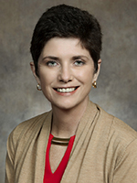 | 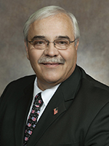 | 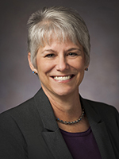
Rep. Rob Swearingen  (Rhinelander) | Rep. Mary Felzkowski  (Irma) | Rep. Jeff Mursau  (Crivitz) | Rep. Beth Meyers  (Bayfield)

NORTHCENTRAL TECHNICAL COLLEGE
(SENATORS)
Senator Tom Tiffany  (Hazelhurst) | Senator Terry Moulton  (Chippewa Falls) | Senator Patrick Testin  (Stevens Point) | Senator Janet Bewley  (Ashland)
Senator Jerry Petrowski  (Marathon) | Senator Rob Cowles  (Green Bay) | Senator Luther Olsen  (Ripon)

NORTHCENTRAL TECHNICAL COLLEGE (REPRESENTATIVES)
Rep. Mary Felzkowski  (Irma) | Rep. Jeff Mursau  (Crivitz) | Rep. Bob Kulp  (Stratford) | Rep. Katrina Shankland  (Stevens Point)
 | 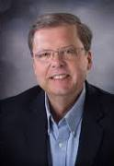
Rep. Beth Meyers  (Bayfield) | Rep. Patrick Snyder  (Wausau) | Rep. John Spiros  (Marshfield) | Rep. Gary Tauchen  (Bonduel)
 | Rep. Kevin Petersen  (Waupaca) | Rep. James Edming  (Glen Flora)

NORTHEAST WISCONSIN TECHNICAL COLLEGE
(SENATORS)
 |  | 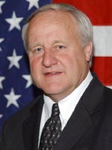
Senator Rob Cowles  (Green Bay) | Senator Tom Tiffany  (Hazelhurst) | Senator Dave Hansen  (Green Bay)

NORTHEAST WISCONSIN TECHNICAL COLLEGE (REPRESENTATIVES)
 |  | 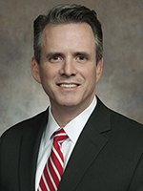
Rep. Joel Kitchens  (Sturgeon Bay) | Rep. Andre Jaque  (Green Bay) | Rep. David Steffen  (Howard) | Rep. Jim Steineke  (Kaukana)
 |  |  | 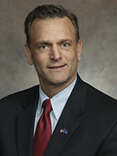
Rep. Gary Tauchen  (Bonduel) | Rep. Rob Swearingen  (Rhinelander) | Rep. Jeff Mursau  (Crivitz) | Rep. John Macco  (De Pere)
 | 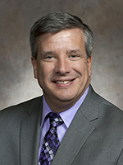 | 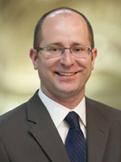
 | Rep. John Nygren  (Marinette) | Rep. Eric Genrich  (Green Bay)

SOUTHWEST WISCONSIN TECHNICAL COLLEGE
 |  | 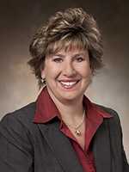
Senator Howard Marklein  (Spring Green) | Senator Jon Erpenbach  (Waunakee) | Senator Jennifer Shilling  (La Crosse)

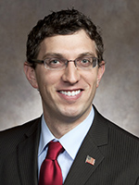
Rep. Travis Tranel  (Cuba City) | Rep. Ed Brooks  (Reedsburg) | Rep. Todd Novak  (Dodgeville) | Rep. Sondy Pope  (Cross Plains)
 | 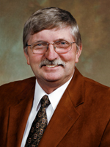
Rep. Lee Nerison
(Westby)

WAUKESHA COUNTY TECHNICAL COLLEGE
(SENATORS)
Senator Leah Vukmir  (Wauwatosa) | Senator Alberta Darling  (River Hills) | Senator Steve Nass  (Whitewater) | Senator Scott Fitzgerald  (Juneau)
 |  | 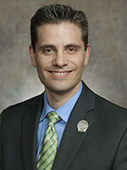
 | Senator Dave Craig  (Big Bend) | Senator Chris Kapenga  (Delafield)

WAUKESHA COUNTY TECHNICAL COLLEGE (REPRESENTATIVES)
Rep. Rob Hutton  (Brookfield) | Rep. Dale Kooyenga  (Brookfield) | Rep. Joe Sanfelippo  (West Allis) | Rep. Janel Brandtjen  (Menomonee Falls)
Rep. Cory Horlacher  (Mukwonago) | Rep. Joel Kleefisch  (Oconomowoc) | Rep. Chuck Wichgers  (Muskego) | Rep. Mike Kuglitsch  (New Berlin)
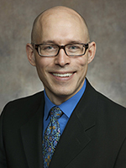 | 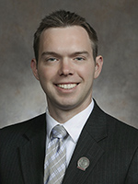 | 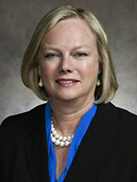
Rep. Scott Allen  (Waukesha) | Rep. Adam Neylon  (Pewaukee) | Rep. Cindi Duchow  (Delafield)

WESTERN TECHNCAL COLLEGE
Senator Howard Marklein  (Spring Green) | Senator Patrick Testin  (Stevens Point) | Senator Kathleen Vinehout  (Alma) | Senator Jennifer Shilling  (La Crosse)

 |  |  | 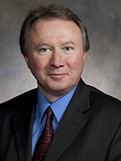
Rep. Ed Brooks  (Reedsburg) | Rep. Nancy VanderMeer  (Tomah) | Rep. Treig Pronschinske  (Mondovi) | Rep. Steve Doyle  (Onalaska)
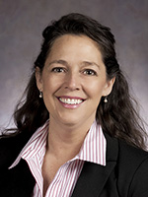
Rep. Jill Billings  (La Crosse) | Rep. Lee Nerison  (Westby) | Rep. Travis Tranel  (Cuba City)

WISCONSIN INDIANHEAD TECHNICAL COLLEGE
Senator Terry Moulton  (Chippewa Falls) | Senator Janet Bewley  (Ashland) | Senator Jerry Petrowski  (Marathon)

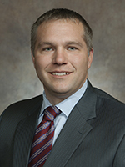 |  |  | 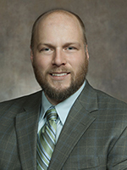
Rep. Adam Jarchow  (Balsam Lake) | Rep. Rob Stafsholt  (New Richmond) | Rep. Shannon Zimmerman  (River Falls) | Rep. Nick Milroy  (South Range)
Rep. Beth Meyers  (Bayfield) | Rep. Romaine Quinn  (Rice Lake) | Rep. James Edming  (Glen Flora)

